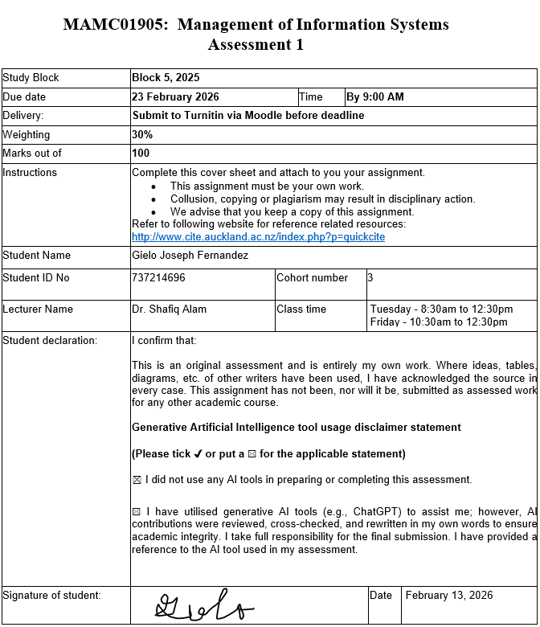

Evolution of the information system for Accounting function in Southern Cross
1. Introduction
In today’s age, accounting plays a huge part in the success of organizations, not just insurance organizations. Accounting can be defined as the scheme and art of collecting, classifying, summarizing, and communicating financial data to facilitate economic decision-making (Muzeyen, 2021). Accounting’s primary purpose is to identify and record economic events, supplying both internal and external users with the information needed to make reasoned choices regarding the allocation of scarce resources (Bakhshi, 2018).
In the insurance sector, Accounting function is uniquely critical due to the high degree of regulatory scrutiny, long-term nature of liabilities, and the necessity of maintaining trust with policyholders (Kuvatova Dinara, 2024).
Southern Cross, leader in providing health insurance to New Zealanders. Southern Cross has different cashflow or services such as life insurance, health insurance, pet insurance, and travel insurance (Southern Cross Healthcare). For Southern Cross, the Accounting Function serves as a strategic business resource that has evolved from routine support to a critical tool for competitive advantage and high-level management inquiries (Demianchuk et al., 2025).
This report will analyse the evolution of Accounting Information Systems(AIS) for Southern Cross. Part two will discuss how AIS is used by Southern Cross as well as the past, current, and future AIS for Southern Cross. And finally close with the summary and conclusion of part three.
2. Accounting function in Southern Cross
The accounting function at Southern Cross involves creating statements such as comprehensive income, financial position, changes in reserves, cash flows, financial statements, etc. (Southern Cross Medical Care Society, 2025). Below, this report is critically evaluating the evolution of the information systems used for Accounting function.
2.1 Past Accounting Information Systems
There are no info regarding the Accounting Information Systems used by Southern Cross in the past. But the common ones are listed below and are used by other insurance companies:
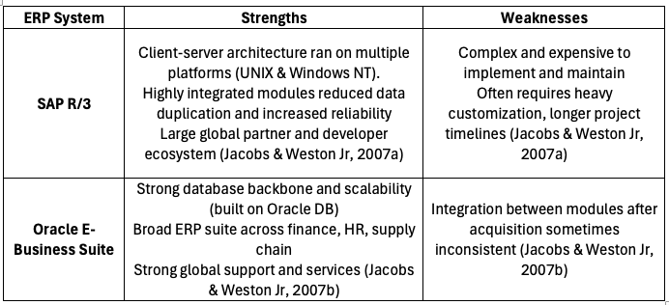
In the 1990s, the adoption of Enterprise Resource Planning (ERP) systems, including products from SAP (SAP R/3), transformed the insurance industry in the 1990s and 2000s by moving organizations from fragmented legacy systems toward integrated information environments (Caglio, 2003). Insurance companies began a significant transition from fragmented legacy systems to integrated Enterprise Resource Planning (ERP) environments, primarily utilizing SAP R/3, which was released in 1992 (Markandeya & Roy, 2014).
Oracle E-Business Suite offered integrated modules for Logistics, Financial Management, Asset Management, and a strong CRM solution (Litan et al., 2011). For insurance marketing and logistics, Oracle provided Oracle Spatial 10g, which could store and manipulate geo-spatial data to geocode customer addresses into maps. Through Oracle GoldenGate, the suite offered a low-overhead architecture to capture transactions in real time for live reporting and operational Business Intelligence (BI) without burdening the production system (Litan et al., 2011).
However, implementing Oracle E-Business Suite systems placed high demands on internal resources and required business managers to learn new IT technical details. Similar to SAP, Oracle integrations resulted in systems that were very complex and difficult to administer or upgrade (Krishnakanthan et al., 2019).
SAP R/3 helped insurers in different business areas such as Financial accounting(general ledger, accounts payable, & treasury management), Human Resources(employee data, payroll, benefits), and Sales & Distribution(Order processing and billing) (Baskaran, 2014). For the advantages of SAP R/3, it facilitated a move away from narrow functional views toward a process view of activities, such as "order-to-cash" or "purchase-to-pay," which integrated tasks across different departments, it provided management with timely and accurate data, aiding in reserve studies, profitability analysis, and strategic planning. It also automated routine tasks, allowing professionals to shift from data gathering to strategic consultation (Caglio, 2003).
However, SAP R/3 is sometimes criticized for being slow and inflexible. Once data is maintained in the system, it can be difficult to correct or amend because the changes ripples through multiple integrated modules and processes. A typical implementation can take 18 months to five years,. The complexity of the system often leads to underestimations of the effort required throughout its life cycle (Birehanu, 2019).
2.2 Current Accounting Information Systems
Currently, Southern Cross has been using Workday to manage their people and finance for the past seven years (Datacom, 2025). But there are various accounting information systems that exists today, including Workday, SAP S/4HANA, Xero, Oracle Net Suite, etc.. The table below discusses each item briefly.
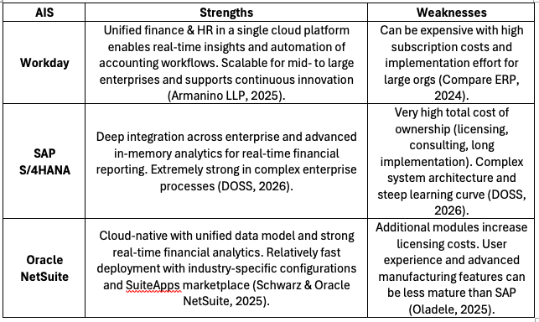
Workday is part of a generation of cloud-native ERPs that incorporate machine learning models directly into financial processes, moving beyond traditional rule-based automation to enable predictive and context-aware operations (Muntala, 2021). Workday leverages machine learning models directly within financial workflows to handle exceptions, identify new patterns, and manage unstructured data, which is often a challenge in manual insurance processing. The system focuses on predictive and context-aware financial management, helping management accountants shift from transactional reporting to strategic decision-making (Dalal, 2020). However, the effectiveness of Workday’s AI features is heavily dependent on high-quality, consistent historical data; inconsistent data can lead to biased outcomes or false positives (Thompson, 2024).
SAP S/4HANA is SAP’s next-generation Enterprise Resource Planning (ERP) suite, built specifically on the SAP S/4HANA in-memory database (Amel, 2025). For the user experience, SAP S/4HANA utilizes SAP Fiori, providing a modern, role-based, and intuitive user experience across mobile and desktop devices (Amel, 2025). For deployment options, SAP S/4HANA can be deployed through on-premise, public cloud, or private cloud (Akkouche et al., 2025).
SAP S/4HANA is designed to act as a digital core that integrates various business functions, including finance, human resources, and supply chain, into a single consistent information system (Banerjee, 2025). For Southern Cross, that would help integrate all the data of each of their services(life, pet, health, travel insurance) into a single information system.
In terms of use of SAP S4/HANA as accounting information systems for Southern Cross. It can handle core accounting tasks such as general ledger, accounts payable, accounts receivable, asset counting, and bank accounting to meet legal and regulatory reporting requirements (Islam, 2019). SAP S/4HANA is also capable of handling billions of records; for instance, large enterprise implementations can have accounting tables exceeding 150 billion records (May et al., 2025).
Advantages of SAP S/4HANA, the system enables near-instantaneous processing of massive data volumes and provides live analytics on transactional data. This allows organizations to move from retrospective reporting to predictive and proactive decision-making (Akkouche et al., 2025). Through the SAP Fiori interface, the system offers a modern, role-based, and device-independent UX that simplifies complex tasks and increases employee productivity (Raikar & Apelagunta, 2025). For Southern Cross, this enables them to view live data, dashboards and make proper business decisions.
However, implementation of SAP S/4HANA presents several limitations. First is that transition to SAP S/4HANA includes expensive software licensing, infrastructure upgrades, and substantial fees for specialized external consultants (Amel, 2025). Third is that heavy reliance on SAP-native tools and cloud infrastructure creates a risk of vendor dependency, potentially limiting an organization's future flexibility and negotiating power (Rao, 2025).
2.3 Future Accounting Information Systems
The future of accounting information systems(AIS) is trending towards transitioning from manual record-keeping to intelligent, real time, decentralized ecosystems (Han et al., 2023). For Southern Cross, that means more and more of their accounting information systems gets automated and this allows Southern Cross to focus on other things. Right now the key emerging trends includes Artificial Intelligence(AI) & Machine Learning(ML) , Blockchain & Triple-Entry Accounting, Big Data Analytics, Internet of Things(IoT), Continuous Auditing, and Robotic Process Automation.
For Southern Cross, Artificial Intelligence(AI) and Machine Learning(ML) automates mundane and repetitive tasks like data entry, transaction categorization, and reconciliation, which significantly reduces human error and operational costs (Ebirim et al., 2024). AI-driven predictive analytics enable accountants to forecast future trends and provide more insightful strategic advice rather than just reporting historical data. Also, it enhances fraud detection by identifying anomalies in large datasets that would be impossible for humans to spot (Mediaty et al., 2024).
Blockchain and Triple-entry Accounting allows for more security in recording transactions. Blockchain is a decentralized, distributed ledger that provides a secure way to record transactions. It is paving the way for triple-entry accounting, where a third, cryptographically secured entry is added to a shared blockchain (Han et al., 2023). This allows immutability and transparency, creating a single source of truth that eliminates the need for extensive ledger reconciliation between different organizations. It reduces information asymmetry between firms and stakeholders and enables smart contracts, which automatically execute transactions when pre-defined conditions are met, thereby increasing efficiency and reducing intermediary costs (Satjawisate et al., 2025). For Southern Cross, they could utilize this to have only a single document between other institutions(i.e. government, clients, other insurers).
Big Data Analytics provides deeper actionable insights into consumer behaviour and market trends, allowing for objective, data-driven decision-making. Predictive risk management models help accountants proactively identify potential financial threats before they manifest (Ebirim et al., 2024). For Southern Cross, this helps them identify threats before they happen which could help with disaster recovery and mitigation.
Continuous Auditing, driven by AI and blockchain, this helps auditors to monitor entire populations of transactions in near real-time, identifying exceptions and risks instantaneously. This provides enhanced assurance and trust in financial reporting while reducing the lag between an event and its detection (Parra-Domínguez et al., 2025). This helps provide assurance from both Southern Cross and their clients & customers.
3. Summary and Conclusion
From the perspective of Southern Cross, the evolution of Accounting Information System from the manual ledgers to the more sophisticated systems transformed how data helps with decision making. Today, Southern Cross is currently using Workday, but other AIS like SAP S/4HANA can provide real-time analytics, predictive analytics, and integration across all services (Amel, 2025). Looking ahead, AI & ML, Blockchain & Triple-entry Accounting, and continuous auditing will further advance the Accounting information System for Southern Cross.

4. References
Akkouche, R. Y., Boussafi, K., & Chehbi Gamoura, S. (2025, November). Confronting the Challenges of Digital Transformation in the Oil and Gas Industry: Case of SAP S/4HANA at Sonatrach. International Conference on Artificial Intelligence Applications in Management and Engineering (ICAIAME’25).
Amel, M. B. (2025). The Simultaneous Management of Multiple SAP S4/HANA Implementation Projects: CAS: PwC.
Bakhshi, S. A. (2018). Accounting system and financial for insurance companies (Case study in the Kurdistan Regional Iraq). Bingol University, Institute of Social Sciences.
Banerjee, D. (2025). Accelerating Business Transformation of Enterprises by Leveraging SAP. SSRN.
Baskaran, B. (2014). Added Value Framework and Information Technology Capabilities of Enterprise Application Integration: A Study on ERP, CRM and Multi-Channel Commerce application integration in Fast Moving Consumer Goods (FMCG) Industry [Master’s thesis]. Delft University of Technology.
Birehanu, D. (2019). Implementation of Enterprise Resource Planning – It’s Challenges: The Case of Awash Insurance Company [Doctoral dissertation]. St. Mary’s University.
Caglio, A. (2003). Enterprise resource planning systems and accountants: Towards hybridization? European Accounting Review, 12(1), 123–153.
Dalal, A. (2020). Harnessing the Power of SAP Applications to Optimize Enterprise Resource Planning and Business Analytics.
Datacom. (2025). Datacom helping Southern Cross get more out of their Workday. https://datacom.com/nz/en/discover/customer-story/datacom-helping-southern-cross-get-more-out-of-their-workday
Demianchuk, M. A., Savastieieva, O. M., & Kuruch, O. V. (2025). Big Data and artificial intelligence in accounting and information systems of insurance business stakeholders.
Ebirim, G. U., Unigwe, I. F., Oshioste, E. E., Ndubuisi, N. L., Odonkor, B., & Asuzu, O. F. (2024). Innovations in accounting and auditing: A comprehensive review of current trends and their impact on U.S. businesses. International Journal of Science and Research Archive, 11(1), 965–974.
Han, H., Shiwakoti, R. K., Jarvis, R., Mordi, C., & Botchie, D. (2023). Accounting and auditing with blockchain technology and artificial intelligence: A literature review. International Journal of Accounting Information Systems, 48, 100598.
Islam, Md. A. (2019). SAP FICO in Relation with Order Delivery Process in Enterprise Resource Planning: A Case Study on SAP S/4HANA System Environment as a Practical Platform.
Krishnakanthan, K., Lansing, J., Münstermann, B., Olesen, P. B., & Vogelgesang, U. (2019). IT Modernization in Insurance: Three Paths to Transformation. McKinsey & Company, Insurance Practice. https://www.mckinsey.com/capabilities/financial-services/our-insights/it-modernization-in-insurance-three-paths-to-transformation
Kuvatova Dinara. (2024). Theoretical Foundations of Accounting of Income and Expenses of Insurance Organizations. World Bulletin of Management and Law, 38, 1–4.
Litan, D., Velicanu, M., Copcea, L., Teohari, M., Mocanu, A., Surugiu, I., & Raduta, O. (2011). Business’ new requirement: Information systems integration – methods and technologies. International Journal of Computers and Communication, 3(5), 133–145.
Markandeya, S., & Roy, K. (2014). ERP and SAP Overview. In S. Markandeya & K. Roy (Eds.), SAP ABAP: Hands-On Test Projects with Business Scenarios (pp. 1–20). Apress. https://doi.org/10.1007/978-1-4302-4804-0_1
May, N., Böhm, A., Ritter, D., Renkes, F., Andrei, M., & Lehner, W. (2025). SAP HANA Cloud: Data Management for Modern Enterprise Applications. 580–592.
Mediaty, M., Indrijawati, A., Kohar, Y. P., Sutriani, S., & Salsabila, T. (2024). Review of artificial intelligence in accounting: Trends, implementation and implications. Journal of Accounting and Finance Management, 5(5), 1146–1160.
Muntala, P. S. R. P. (2021). Integrating AI with Oracle Fusion ERP for Autonomous Financial Close. International Journal of AI, BigData, Computational and Management Studies, 2(2), 76–86.
Muzeyen, R. (2021). Accounting information system practice and its impact on accounting and audit reporting quality: Case study in Awash Insurance Company S.C. [Doctoral dissertation]. St. Mary’s University.
Parra-Domínguez, J., Sanz Martín, L., López Pérez, G., & Zafra Gómez, J. L. (2025). The disruption of blockchain technology in accounting: A review of scientific progress. Journal of Accounting & Organizational Change, 21(7), 330–362.
Raikar, T., & Apelagunta, V. (2025). Implementing SAP Fiori in S/4HANA Transitions: Key Guidelines, Challenges, Strategic Implications, AI Integration Recommendations. Journal of Engineering Research and Sciences, 4(11), 1–9. https://doi.org/10.55708/js0411001
Rao, N. (2025). Hybrid Cloud Integration in SAP Landscapes: Ensuring Reliable Digital Transformation. Journal Of Engineering And Computer Sciences, 4(11), 105–118.
Satjawisate, S., Suriyapaiboonwattana, K., Saramolee, A., & Hone, K. (2025). Digital competencies for a FinTech-driven accounting profession: A systematic literature review. Informatics, 12(4), 121.
Southern Cross Healthcare. About us. Southern Cross Healthcare. https://healthcare.southerncross.co.nz/about-us
Southern Cross Medical Care Society. (2025). Southern Cross Medical Care Society Group Financial Statements for the Year Ended 30 June 2025. Southern Cross Medical Care Society. https://www.southerncross.co.nz/-/media/files/corporate/annual-reports/scmcs_financial_statement_2025.pdf
Thompson, B. A. G. (2024). Enhancing Healthcare Financial Decision-Making using Secure AI-Enabled SAP Cloud Platforms. International Journal of Research and Applied Innovations, 7(3), 10748–10754.

